**Asignment 5**

1. **In your words, describe the difference between Common Cathode and Common Anode 7-segment display.**

In Common Anode configuration all the anodes of LEDs are connected together, to turn ON the individual segments logic ‘0’ is applied. But in Common Cathode configuration all cathodes of LEDs are connected together and to turn ON the individual segments logic 1 or HIGH is applied.

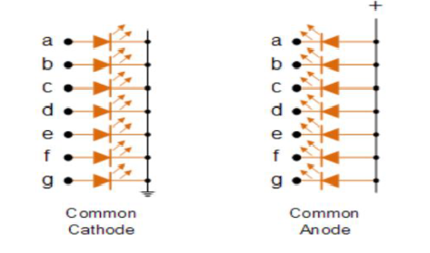

1. **Code listing with syntax highlighting of two interrupt service routines (TIMER1_OVF_vect, TIMER0_OVF_vect) from counter application with at least two digits, ie. values from 00 to 59:**

/**********************************************************************

* Function: Timer/Counter1 overflow interrupt

* Purpose: Increment counter value from 00 to 59.

**********************************************************************/

ISR(TIMER1_OVF_vect)

{

cnt0++;

if (cnt0 >= 10) // Reached 10 seconds

{

cnt0 = 0;

cnt1++;

}

if (cnt1 >= 6) // If the stopwatch has reached 60 seconds

{

cnt0 = 0; // Decimal value 0

cnt1 = 0; // Ten value 0 (Ten value of seconds)

cnt2++; // Increase in minute (60 seconds has passed)

}

if (cnt2 >= 10) // If 10 minute have passed

{

cnt0 = 0;

cnt1 = 0;

cnt2 = 0; // Decimal value of minutes = 0

}

/**********************************************************************

* Function: Timer/Counter0 overflow interrupt

* Purpose: Display tens and units of a counter at SSD.

**********************************************************************/

ISR(TIMER0_OVF_vect)

{

static uint8_t pos = 0;

if (pos == 0)

{

SEG_update_shift_regs(cnt0, pos);

pos = 1; // Ready to move to second SSD

}

else if (pos == 1)

{

SEG_update_shift_regs(cnt1, pos);

pos = 2; // Position changed to third SSD

}

else if (pos == 2)

{

SEG_update_shift_regs(cnt2, pos);

pos = 3; // POSITION CHANGED TO 4TH SSD

}

else if (pos == 3)

{

SEG_update_shift_regs(cnt3, pos);

pos = 0; // POSITION CHANGED TO FIRST SSD

}

}

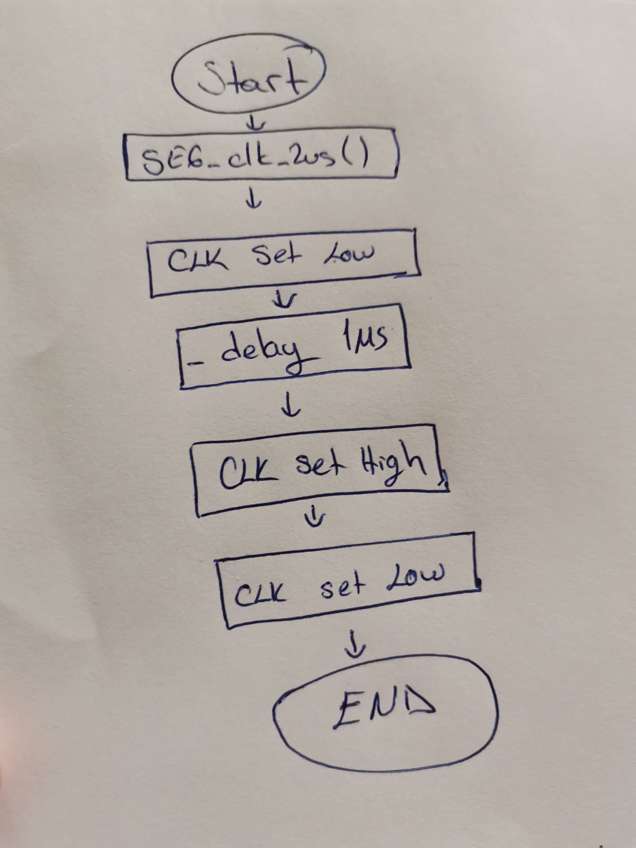

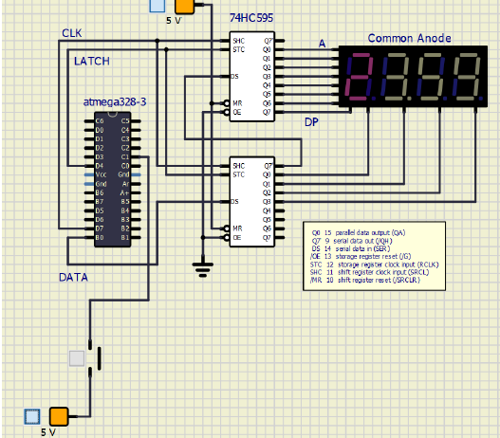

Preparation the next lecture:

|  |  |  |  |  |  |  |  |  |
| --- | --- | --- | --- | --- | --- | --- | --- | --- |
| **Digit** | **A** | **B** | **C** | **D** | **E** | **F** | **G** | **DP** |
| 0 | 0 | 0 | 0 | 0 | 0 | 0 | 1 | 1 |
| 1 | 1 | 0 | 0 | 1 | 1 | 1 | 1 | 1 |
| 2 | 0 | 0 | 1 | 0 | 0 | 1 | 0 | 1 |
| 3 | 0 | 0 | 0 | 0 | 1 | 1 | 0 | 1 |
| 4 | 1 | 0 | 0 | 1 | 1 | 0 | 0 | 1 |
| 5 | 0 | 1 | 0 | 0 | 1 | 0 | 0 | 1 |
| 6 | 0 | 1 | 0 | 0 | 0 | 0 | 0 | 1 |
| 7 | 0 | 0 | 0 | 1 | 1 | 1 | 1 | 1 |
| 8 | 0 | 0 | 0 | 0 | 0 | 0 | 0 | 1 |
| 9 | 0 | 0 | 0 | 0 | 1 | 0 | 0 | 1 |